Name: Soumyadip Ghosh
Registration No.: 23BCB0067
Course: Web Programming (BCSE203E)
Review 1 : Web Application Architecture Design – HTML and CSS Design Document.

SITEMAP

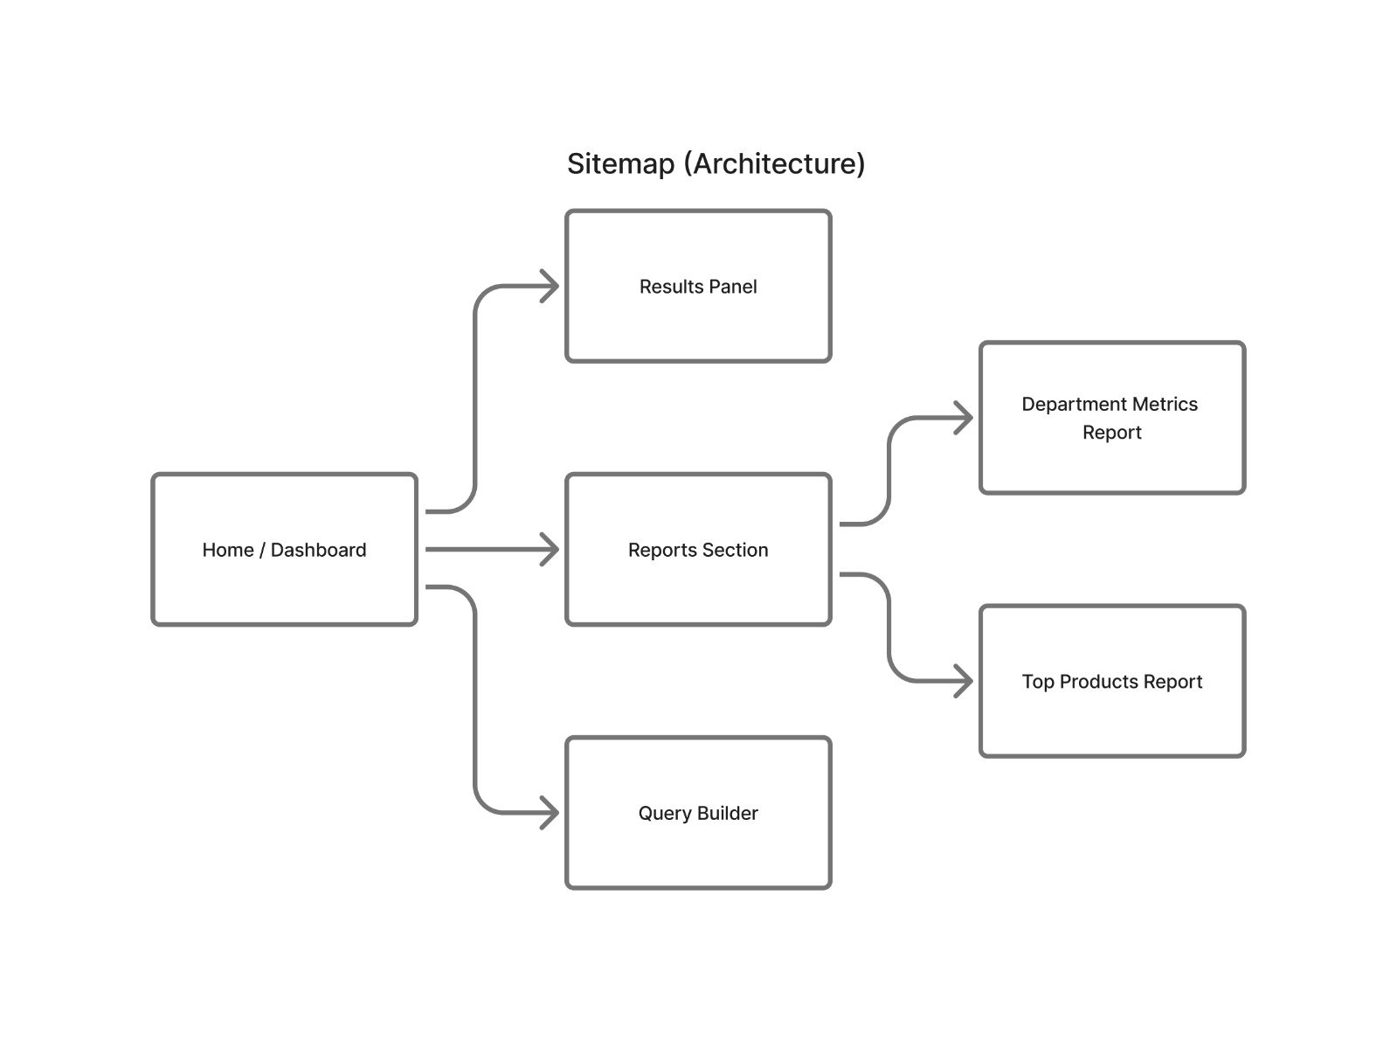

WIREFRAME

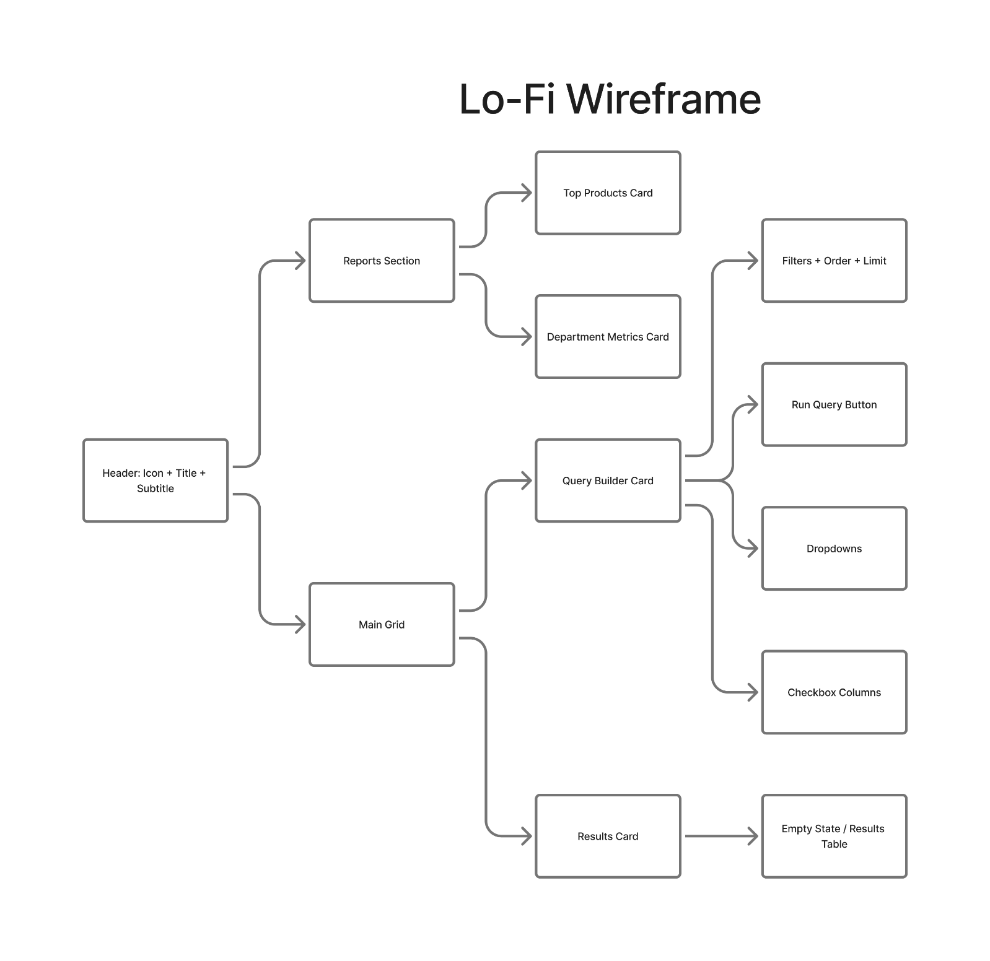

SEMANTIC LAYOUT

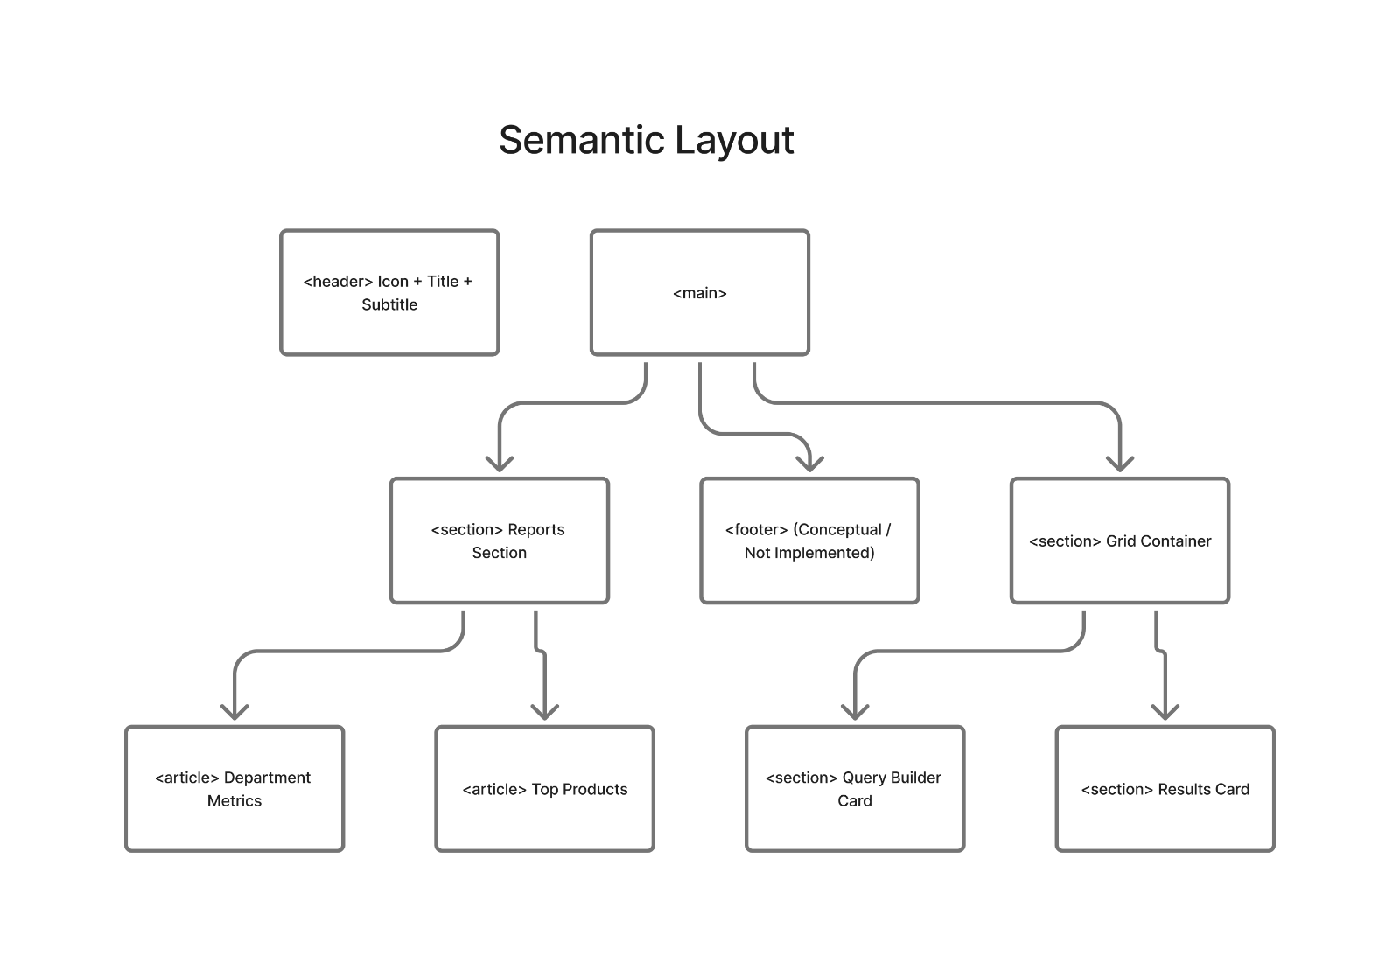

HI-FI MOCKUP

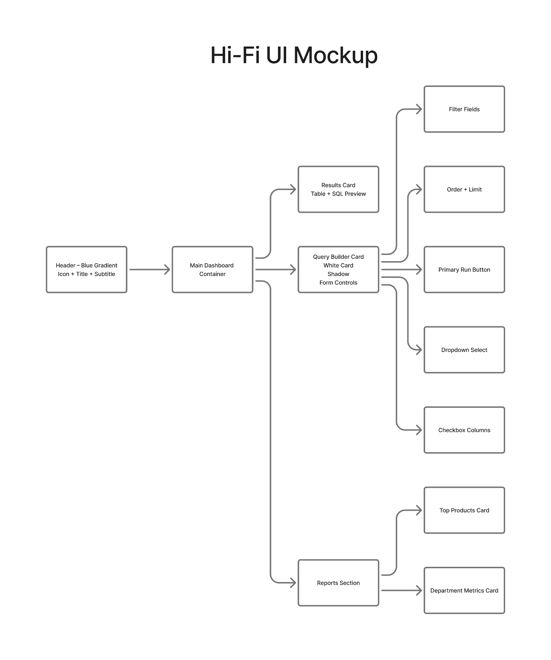

UI

